

# December 2017 Update

# **The PK Study**

**The Project**

Aboriginal Australians experience worse graft and patient outcomes following kidney transplantation compared with Caucasian Australians. Drug metabolism differences have been found between racial groups, meaning different doses are required for each group. Data suggests that immunosuppressant drug metabolism might be different in Aboriginal patients. Are we over suppressing their immune systems?

This project aims to investigate whether differences exist in the way Aboriginal and Caucasian kidney transplant recipients process immunosuppressant medications and if genetics plays a role.

**Project Team**

The project is multi-site collaboration between Central Northern Adelaide Renal, Fiona Stanley Hospital and NT Renal Services at Alice Springs and Royal Darwin Hospitals. The project team is led by Dr Katherine Barraclough, a Consultant Nephrologist at the Royal Melbourne Hospital. The study is project managed by Menzies Renal Team of Gillian Gorham and Charles Triggs.

**Key Contact:**Charles Triggs - Research Assistant   
Web: [www.menzies.edu.au](http://www.menzies.edu.au)  
E: charles.triggs@menzies.edu.au   
Ph: 08 8946 8666

**Recruitment**

As the year comes to an end recruitment for the PK Study can begin in earnest, as the site coordinators have received approval from ethics and governance committees at each of the four sites. To date 12 kidney transplant patients have been recruited and participated in the biological sampling process. The required sample size for this project is 80 participants in total meaning that recruitment will be a priority over the coming months.

A recent transition to a new campus location for the Royal Adelaide Hospital hindered recruitment capacity for the site for a short time, however recruitment is back on track now that the move has concluded. Alice Springs Hospital has had similar difficulties in recruitment due to an asbestos contamination in the pathology department.

Despite these difficulties in recruitment we expect to recruit another 10 participants before the end of the year. In order to ease the recruitment process we have made amendments to the inclusion criteria in the research protocol to allow for a greater window of time post-transplant.

Figure 1: Study sites and laboratories involved in the study

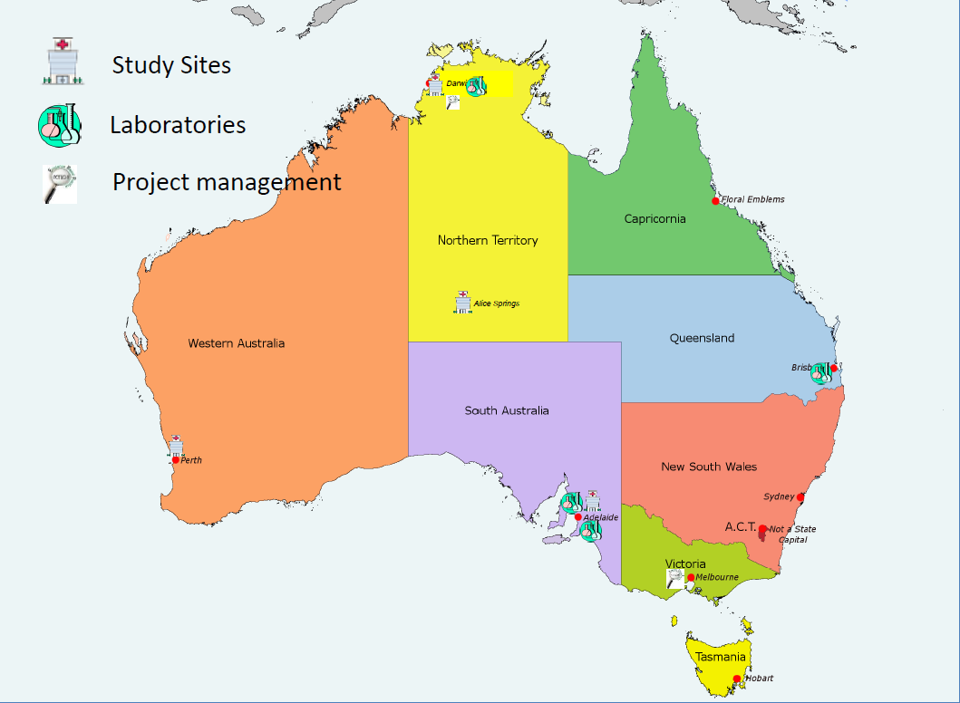

**Project Coordination**

The project is running efficiently with consistent reporting from all sites. The project team expects that the project will be completed by the approved completion date, 30/11/2018.

The project and team